**Name: Ankur Prajapati**

**StudentID: N01324892**

**Lab Assignment - 2**

Practice 1: writing executable Statements

1. Evaluation of code:

|  |  |  |
| --- | --- | --- |
| Question | Data Type | Value |
| A | NUMBER (3) | 2 |
| B | VARCHAR2 (50) | Western Europe |
| C | NUMBER (3) | 3 |
| D | VARCHAR2 (255) | Product 11001 is in stock |
| E | VARCHAR2 (50) | Western Western Europe |

1. Evaluation of Code:

|  |  |  |
| --- | --- | --- |
| Question | Data Type | Value |
| A | NUMBER (7) | 201 |
| B | VARCHAR2 (25) | Unisports |
| C | VARCHAR2 (50) | GOOD |
| D | VARCHAR2 (50) | Womansport |
| E |  | Will give an Error |
| F | VARCHAR2 (50) | EXCELLENT |

1. Edit the above Script:

Part a answer:

--VARIABLE b_basic_percent NUMBER

--VARIABLE b_pf_percent NUMBER

Part b answer:

/*:b_basic_percent := 45;

:b_pf_percent := 12;*/

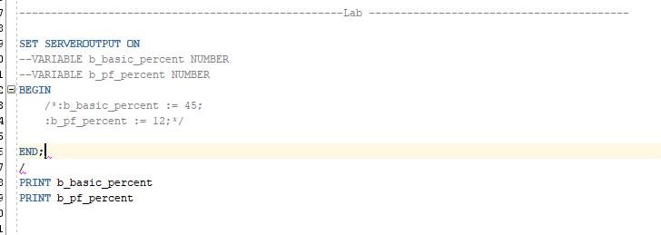

Practice 2: Use above Script and Edit it as follow:

1. Declaration of Variable

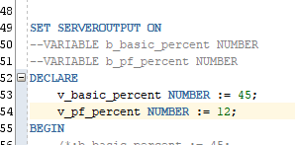

1. Declaration of 2 additional variables

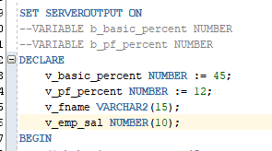

2(d)

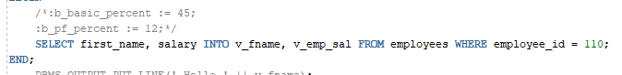

2(e)

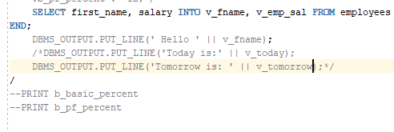

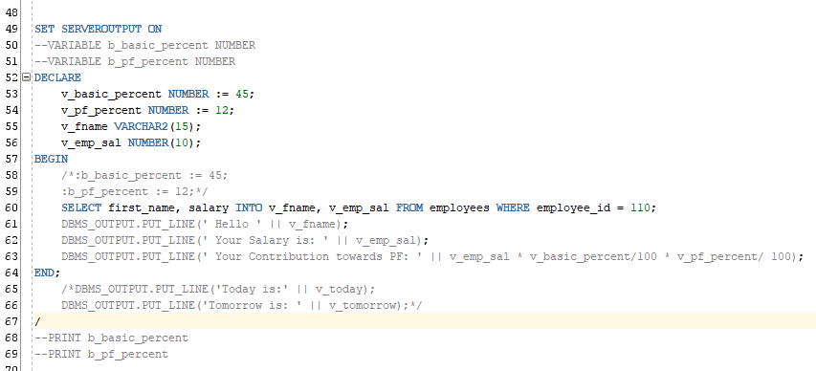2(f)

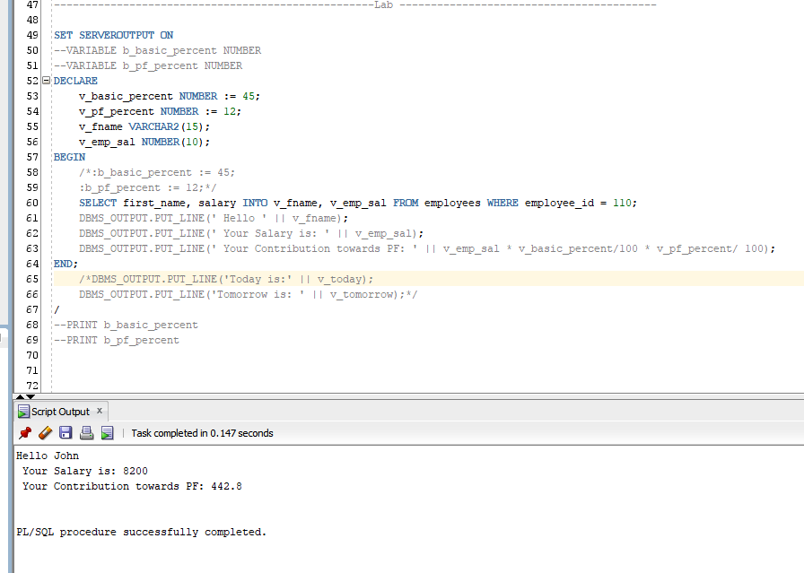2(g)

Practice 3:

1. Identify the Errors in the code:

DECLARE

"WORLD" VARCHAR2(10) := 'world';

"DECLARE" VARCHAR2(10) := 'declare';

BEGIN

DBMS_OUTPUT.Put_Line(World);

DBMS_Output.Put_Line("Declare");

end;

/

Error:

identifier 'Declare' must be declared.

Gives a compilation Error.

1. 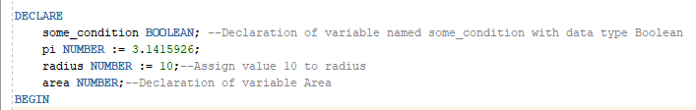Add a single Line comment to wherever applicable
2. Add the multi-line comments to the following block.

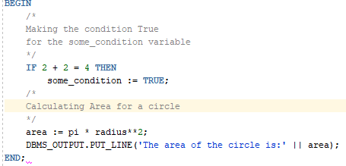

1. Analyse the code and comment on the operator precedence and parentheses used in expressions:
2. DBMS_OUTPUT.PUT_LINE(‘8 + 20 / 4 = ’ || (8 + 20 / 4)); and   
   DBMS_OUTPUT.PUT_LINE((‘20 / 4 + 8 = ’ || (20 / 4 + 8)));

**In these first / gets executed and after that + gets executed.**

1. DBMS_OUTPUT.PUT_LINE((‘7 + 9 / 3 = ’ || (7 + 9 / 3)));

**In this first / gets executed and then after that +.**

1. DBMS_OUTPUT.PUT_LINE((‘7 + 9 / 3 = ’ || (7 + 9 ) / 3));

**In this () will be executed first that means 7+9 and after that the / gets executed that means 16/3.**

1. DBMS_OUTPUT.PUT_LINE(‘(salary * 0.08) + (commission * 0.12) = ’ || (salary * 0.08) + (commission * 0.12));

**In this both the () gets executed first.**

**That means (salary * 0.08) and (commission * 0.12)**

**After that the + get executed: (salary * 0.08) + (commission * 0.12)**

1. DBMS_OUTPUT.PUT_LINE(‘salary * 0.08 + commission * 0.12 = ’ || (salary * 0.08 + commission * 0.12));

**In this the * gets executed first and after that the + gets executed.**